**Portion for UT2**

|  |  |  |  |  |  |  |
| --- | --- | --- | --- | --- | --- | --- |
| **HCSC501.4** | | Apply the knowledge of network reconnaissance to perform Network and web application-based attacks. | | L2 | | |
| **HCSC501.5** | | Apply the concepts of hardware elements and endpointsecurity to provide security to physical devices. | | L2 | | |
| IV | **Introduction to web security and Attacks** | | OWASP, Web Security Considerations, User Authentication, Cookies, SSL, HTTPS, Privacy on Web, Account Harvesting, Web Bugs, Sniffing, ARP poisoning, Denial of service attacks, Hacking Web Applications, Clickjacking, Cross-Site scripting and Request Forgery, Session Hijacking and Management, Phishing and Pharming Techniques, SSO, Vulnerability assessments, SQL injection, Web Service Security, OAuth 2.0, Demonstration of hacking tools on Kali Linux such as SQLMap, HTTrack, hping, burp suite, Wireshark etc. | | **10** | CO4 |
| V | **Elements of**  **Hardware Security** | | Side channel attacks, physical unclonable functions, Firewalls, Backdoors and trapdoors, Demonstration of Side Channel Attacks on RSA, IDS and Honeypots. | | **6** | CO5 |

**Question Set:**

1. **Define OWASP and explain its significance in improving web application security. Provide examples of common vulnerabilities addressed by OWASP.**

The Open Web Application Security Project (OWASP) is an international non-profit organization dedicated to improving web application security. It provides freely-available articles, methodologies, documentation, tools, and technologies in the field of web application security. One of OWASP’s core principles is that all of their materials be freely available and easily accessible on their website, making it possible for anyone to improve their own web application security.

The significance of OWASP in improving web application security is immense. It helps make applications more secure against cyber attacks, reduces the rate of errors and operational failures in systems, contributes to stronger encryption, increases the potential for application success, and improves the image of the software developer company. OWASP maintains a list of the 10 most dangerous web application security holes, along with the most effective methods to address them.

Some common vulnerabilities addressed by OWASP are:

* Injection: Occurs when untrusted data is sent to a code interpreter through a form input or some other data submission to a web application.
* Broken Authentication: Vulnerabilities in authentication (login) systems can give attackers access to user accounts and even the ability to compromise an entire system using an admin account.
* Sensitive Data Exposure: If web applications don’t protect sensitive data such as financial information and passwords, attackers can gain access to that data.
* XML External Entities (XXE): An attack that exploits weakly configured XML processors.
* Broken Access Control: Restrictions on what authenticated users are allowed to do are often not properly enforced.
* Security Misconfigurations: Can happen at any level of an application stack, including the network services, platform, web server, application server, database, frameworks, custom code, and pre-installed virtual machines, containers, or storage.
* Cross-Site Scripting (XSS): XSS flaws occur whenever an application includes untrusted data in a new web page without proper validation or escaping.

These vulnerabilities are regularly updated based on the evolving threat landscape. By addressing these common vulnerabilities, developers can significantly enhance the security of their web applications.

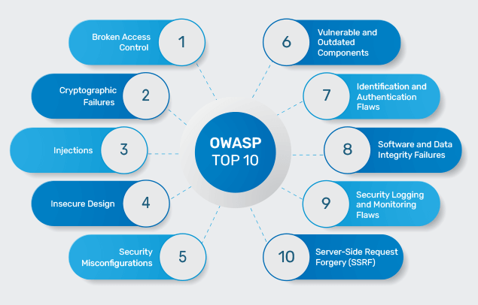

1. **Compare and contrast firewalls and intrusion detection systems (IDS) in terms of their roles in protecting network assets.**

Firewalls and Intrusion Detection Systems (IDS) both play crucial roles in network security, but they function in different ways and offer different types of protection.

Firewalls:

* A firewall is a network security device that monitors all incoming and outgoing traffic.
* It blocks and filters network traffic based on a defined set of security rules.
* Firewalls can be either hardware or software-based.
* They establish a barrier between secured internal networks and outside untrusted networks, such as the Internet.
* Firewalls permit traffic depending on rules set up based on the source, destination, and port addresses.
* They are typically installed inline at the network’s perimeter, making them the first line of defense.

Intrusion Detection Systems (IDS):

* An IDS is a software or hardware device installed on the network to detect and report intrusion attempts.
* Unlike firewalls, IDS are passive monitoring system devices that monitor network traffic as they travel over the network, compare signature patterns, and raise an alarm if suspicious activity or known security threat is detected.
* IDS can only report an intrusion; it cannot block it.
* They detect real-time traffic and search for attack signatures or traffic patterns, then send out alarms.
* IDS are very difficult to be spotted in a network (especially stealth mode of IDS).

In summary, while firewalls control access to a network based on predefined rules, an IDS monitors network traffic for suspicious activity. Both are essential components of a robust network security strategy. They can work together to provide comprehensive protection: the firewall controls access points and blocks unauthorized traffic, while the IDS monitors for signs of any attacks that do get through

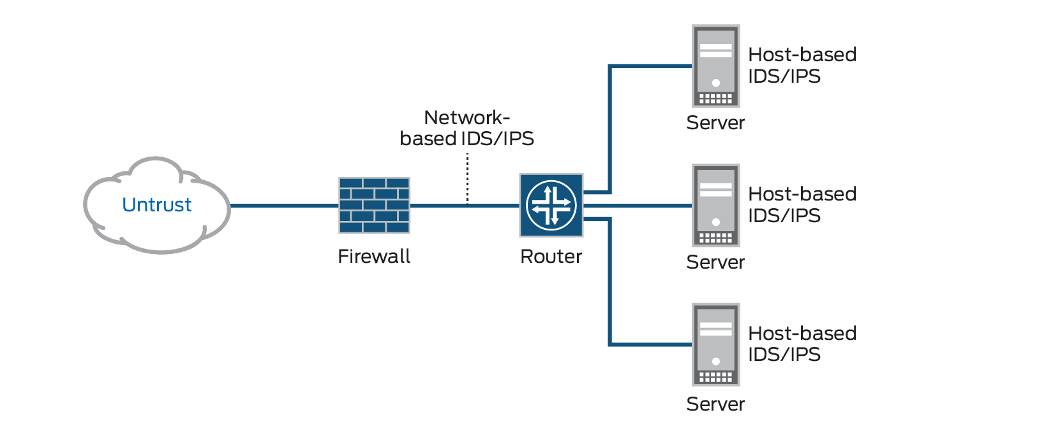

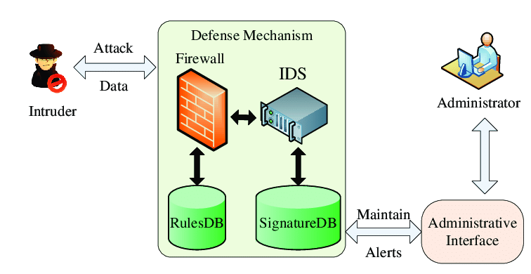

1. **Describe why it is essential to replicate attack scenarios during ethical hacking.**

Replicating attack scenarios during ethical hacking is essential for several reasons:

* Realistic Assessment: By duplicating the techniques and methods followed by malicious hackers, ethical hackers can find out system discrepancies. This provides a realistic assessment of the system’s vulnerabilities.
* Understanding Attack Vectors: Replicating attack scenarios helps in understanding how an attack occurred or may occur. This understanding is crucial in developing effective countermeasures.
* Identifying Weak Points: If ethical hackers find a weak point in the system or network during the replication of an attack scenario, they can report it immediately and fix the flaw.
* Enhancing Security Measures: The major benefit of ethical hacking is that it subjects your system to the same kind of attack that a genuine criminal would employ. This helps in enhancing security measures and defending against possible dangers.
* Out-of-the-box Thinking: Black hat hackers are always looking for new techniques and think outside the box in order to bypass defenses. By replicating these attack scenarios, ethical hackers can come up with ideas that internal security teams haven’t thought of.

In summary, replicating attack scenarios during ethical hacking allows for a comprehensive understanding of potential threats, helping to fortify systems against real-world cyber attacks.

1. **Explain how user authentication enhances web application security and list key factors for implementing authentication mechanisms in a real-world scenario.**

User authentication significantly enhances web application security by verifying the identity of a user or information. This process is used to prove that some fact or some document is genuine, true, or valid. A user confirms their identity by providing their credentials, which are shared between the user and the service or system where authentication is required. For example, when you want to access your Gmail account from a new device, you will need to be authenticated before you can see all of your emails or create a new one.

Key factors for implementing authentication mechanisms in a real-world scenario include:

1. Responding with a “yes” or “no”: Depending on the result of the authentication, rather than sharing and/or exposing Personally Identifiable Information (PII), with the exception of special circumstances.
2. Exception Handling and Grievance Redress Protocols: In case the authentication mechanism fails (e.g., a false negative biometric result), there should be known and easily accessible exception handling and grievance redress protocols.
3. Auditability of Transactions: Facilitate the auditability of transactions, including tamper-proof logs, certifying authentication devices, and identifying relying parties as well as potentially the individual operator within those organizations.
4. Eliminate Opportunities for Tracking or Profiling: The ID authority or other actors should not be able to use transaction metadata to track or profile the ID holder (e.g., through encryption, hashing, anonymization of data, decentralization of such data etc.).
5. Implement Security Controls: Reduce threats such as guessing, eavesdropping, replay or manipulation of communication by an attacker that could subvert the authentication mechanism.

These factors ensure that the authentication process is secure, reliable, and respects user privacy.

1. **Review actual instances where backdoors and trapdoors in software and hardware systems led to ethical concerns, and suggest ethical solutions for these problems.**

Backdoors and trapdoors in software and hardware systems have led to several ethical concerns. For instance, backdoors can be used by hackers, governments, IT people, etc., to remotely access your device without your permission or knowledge. They can be installed by exploiting software vulnerabilities or even by directly installing a backdoor in your device’s hardware/firmware. Once installed, they can be used for surveillance, data theft, cryptojacking, sabotage, and malware attacks.

Trap doors are secret entry points into a program that allow anyone to gain access to a system without going through the usual security access procedures. They are often used legally by programmers for debugging and testing programs. However, they become threats when dishonest programmers gain illegal access.

These instances raise ethical concerns about privacy, consent, and misuse of power. They highlight the need for robust security measures and ethical guidelines in software and hardware development.

Ethical solutions to these problems could include:

1. Transparency: Developers should clearly communicate to users if their software or hardware contains any backdoors or trapdoors for legitimate purposes.
2. Consent: Users should be asked for their consent before any backdoor or trapdoor is used for administrative or troubleshooting processes.
3. Strong Security Measures: Implementing strong firewalls, using strong passwords, and continuously monitoring the security system can help prevent backdoor attacks.
4. Regular Updates: Keeping software up-to-date can help protect against known vulnerabilities that could be exploited to install backdoors.
5. Education: Raising awareness about cyber attacks can help prevent them to a large extent.

By adhering to these ethical solutions, we can ensure that technology serves its intended purpose without compromising user privacy and security.

1. **Use your understanding of simulating social engineering attacks to create a step-by step plan for executing such an attack. Afterward, analyze the effectiveness of the attack simulation, including both successful and unsuccessful elements.**
2. Social engineering penetration testing focuses on people and processes and the vulnerabilities associated with them.
3. These pen tests typically consist of an ethical hacker conducting different social engineering attacks such as phishing, USB drops, or impersonation that a person could face during the course of their work.
4. The goal of this test is to identify weaknesses in a person, group of people, or process and identify vulnerabilities with a clear path to remediation.

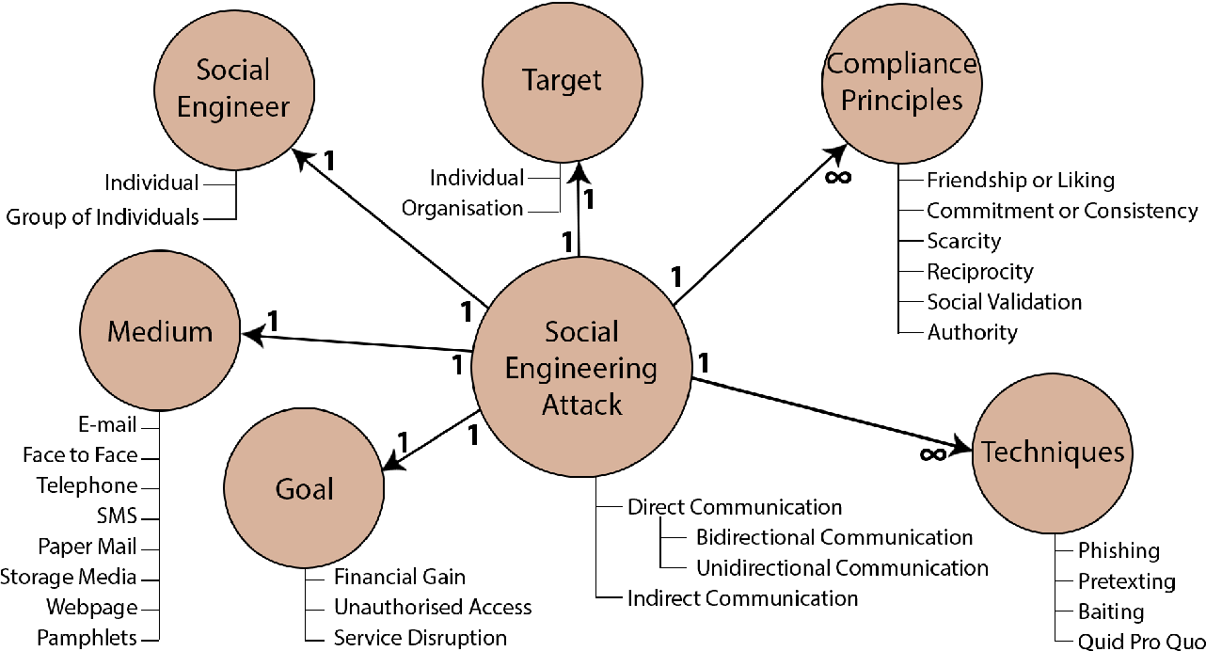

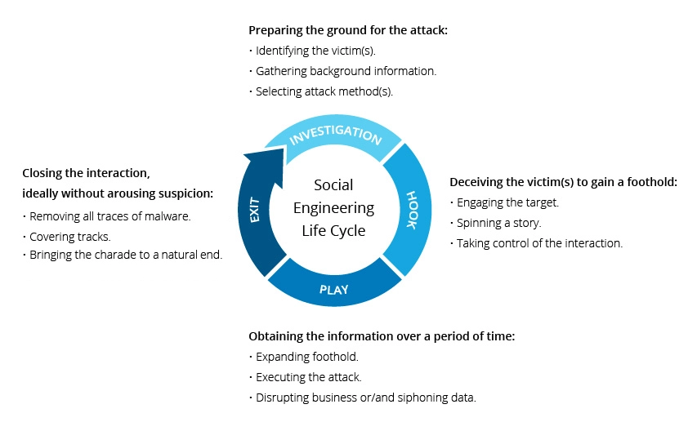

1. **Discuss the purpose of using SSL and HTTPS in web communication and how they contribute to securing sensitive data.**

Secure Socket Layer (SSL) and Hypertext Transfer Protocol Secure (HTTPS) are both integral to secure web communication.

SSL provides security to the data that is transferred between a web browser and server. It encrypts the link between a web server and a browser, ensuring that all data passed between them remains private and free from attack1. SSL uses a system of two keys to encrypt communications: a public key known to everyone and a private or secret key known only to the recipient of the message.

HTTPS, on the other hand, is the secure version of HTTP, which is the primary protocol used to send data between a web browser and a website. HTTPS is encrypted in order to increase the security of data transfer, particularly important when users transmit sensitive data, such as by logging into a bank account, email service, or health insurance provider.

When it comes to securing sensitive data, SSL and HTTPS play crucial roles. They prevent websites from having their information broadcast in a way that’s easily viewed by anyone snooping on the network. When information is sent over regular HTTP, the information is broken into packets of data that can be easily “sniffed” using free software. With HTTPS, traffic is encrypted such that even if the packets are sniffed or otherwise intercepted, they will come across as nonsensical characters. This ensures that sensitive data like credit card numbers or login credentials remain safe and only visible to the intended recipient.

In conclusion, SSL and HTTPS are essential for maintaining privacy, authentication, and data integrity in Internet communications. They protect user privacy by encrypting any data that goes between a user and a web server, ensuring that anyone who intercepts the data can only see a scrambled mess of characters.

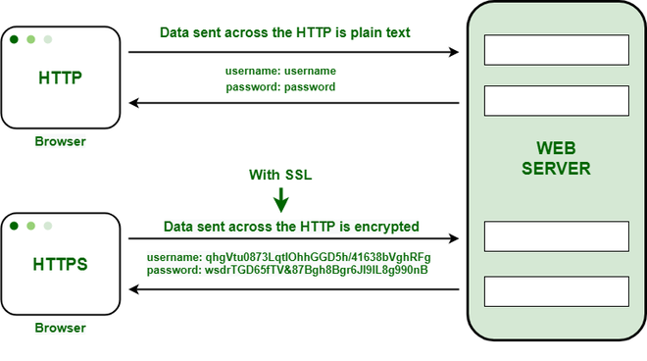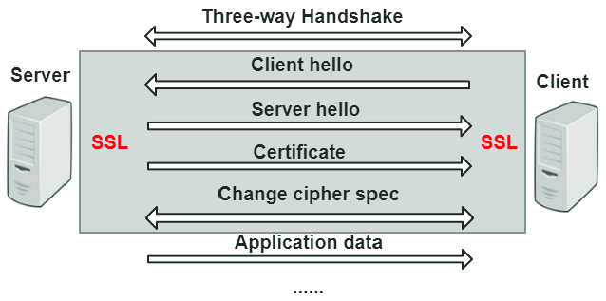

1. **Analyze the privacy challenges associated with online activities and propose measures to protect user privacy on the web**

Online activities pose several privacy challenges:

1. Spying and Snooping: When you are online, you are spied on by a number of trackers for various purposes. Trackers keep a record of your search history and track all your online activities through various means. This provides them a clear picture of who you are and your interests, which is a breach of online privacy policy and makes you a public property.
2. Information Mishandling: There are various sites on the internet that need your personal information to get access to their services. These sites often store cookies and save your personal information and later use it for various purposes. Most of the time this information is not encrypted and can be accessed by anyone.
3. Location Tracking: Most of the internet users proudly upload their social media posts highlighting their current location along with tagging friends and family members. By turning on your location you are providing first-hand information to the world about where exactly you are and what your next move is, which is certainly risky and insecure.

To protect user privacy on the web, the following measures can be taken:

1. Share less information with apps and services: Be mindful of the information you share with apps and services. Only provide necessary information.
2. Use strong and unique passwords with 2FA: Use strong, unique passwords for each of your accounts, and enable two-factor authentication (2FA) whenever possible.
3. Tighten privacy settings on your social media accounts: Regularly review and update the privacy settings on your social media accounts to control who can see your posts and personal details2.
4. Delete unused accounts, apps, and browser extensions: Unused accounts, apps, and browser extensions can pose a security risk if they’re compromised. Regularly review your accounts, apps, and extensions, and delete those you no longer use.
5. Stop search engines from tracking you: Use privacy-focused search engines that don’t track your search history.
6. Use a VPN to hide your browsing history: A Virtual Private Network (VPN) can help hide your browsing history from your internet service provider or anyone else who might be monitoring your network.
7. Update virus protection, use security settings, download patches, install a firewall, screen email, shut down spyware, control cookies, use encryption, fend off browser hijackers, block pop-ups.
8. Use tools such as anonymity, anti-tracking, and browser plugins to ensure protection from third-party tracking methods by blocking JavaScript programs and other website components.

**9. Describe the significance of physical unclonable functions (PUFs) in hardware security and how they contribute to device authentication.**

Physical Unclonable Functions (PUFs) are a significant technique in hardware security that exploits inherent device variations to produce an unclonable, unique device response to a given input1. They can be thought of as analogous to biometrics for humans – they are inherent and unique identifiers for every piece of silicon.

PUFs exploit inherent delay characteristics of wires and transistors that differ from chip to chip, and describe how PUFs can enable low-cost authentication of individual Integrated Circuits (ICs) and generate volatile secret keys for cryptographic operations.

Rather than embodying a single cryptographic key, PUFs implement challenge–response authentication. When a physical stimulus is applied to the structure, it reacts in an unpredictable (but repeatable) way due to the complex interaction of the stimulus with the physical microstructure of the device. This makes PUFs a more foolproof way to build security into hardware.

For device authentication, PUFs work as follows:

* Challenge: Manufacturer puts the PUF to a series of “challenges”.
* Response: Manufacturer observes and records the response to each input challenge.
* Implementation: A counterfeit wouldn’t “pass” any of the manufacturer’s challenges as it would produce its own unique responses, deviating from the recorded ones.

In conclusion, PUFs offer numerous advantages over standard cryptographic techniques. They generate random numbers on demand, such as during device authentication. IDs created this way are more difficult to view and decipher. They are ideal for building hardware-rooted security, such as in ICs.

